Prescott Fire Cache(Google maps link)
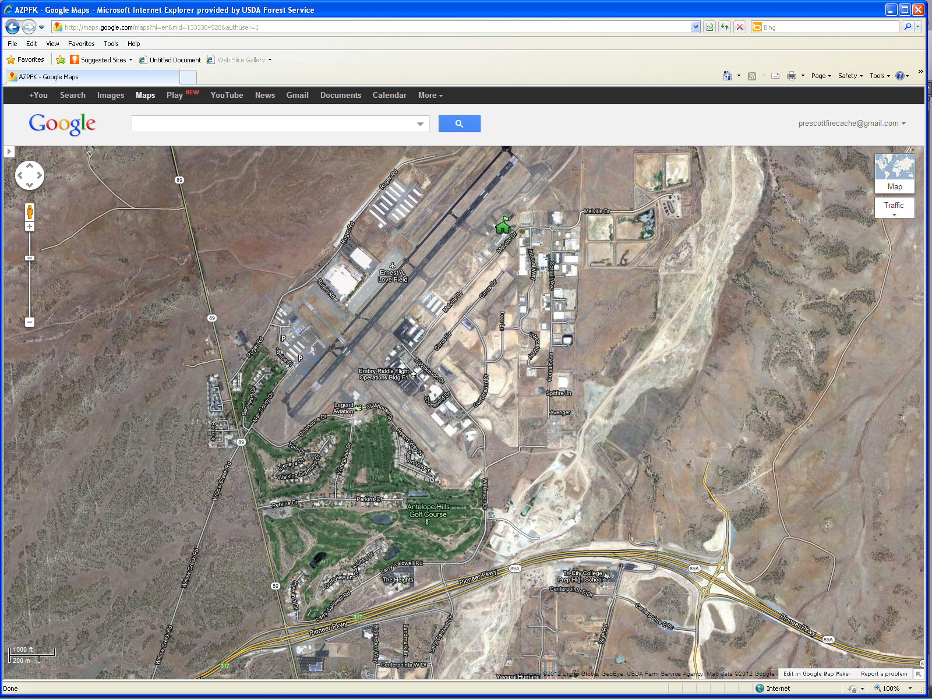
Prescott Fire Cache 2400 Melville Dr.
89A

To Prescott
Larry Caldwell Dr. Exit
89
Melville Dr

